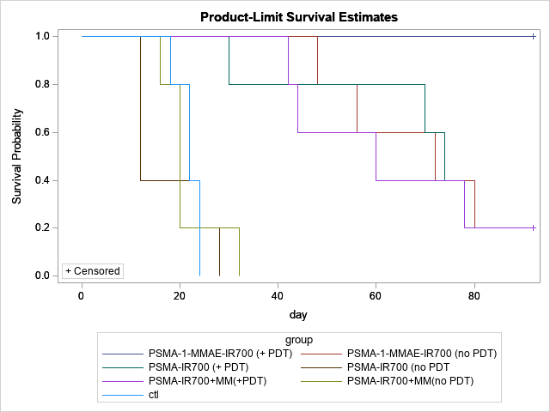

|  |  |  |  |  |
| --- | --- | --- | --- | --- |
| Adjustment for Multiple Comparisons for the Logrank Test | | | | |
| Strata Comparison | | **Chi-Square** | **p-Values** | |
| group | **group** | **Raw** | **Sidak** |
| PSMA-1-MMAE-IR700 (+ PDT) | **PSMA-1-MMAE-IR700 (no PDT)** | 2.7004 | 0.1003 | 0.8914 |
| PSMA-1-MMAE-IR700 (+ PDT) | **PSMA-IR700 (+ PDT)** | 2.8382 | 0.0920 | 0.8684 |
| PSMA-1-MMAE-IR700 (+ PDT) | **PSMA-IR700 (no PDT** | 19.2474 | <.0001 | 0.0002 |
| PSMA-1-MMAE-IR700 (+ PDT) | **PSMA-IR700+MM(+PDT)** | 3.3898 | 0.0656 | 0.7595 |
| PSMA-1-MMAE-IR700 (+ PDT) | **PSMA-IR700+MM(no PDT)** | 17.4816 | <.0001 | 0.0006 |
| PSMA-1-MMAE-IR700 (+ PDT) | **ctl** | 16.1638 | <.0001 | 0.0012 |
| PSMA-1-MMAE-IR700 (no PDT) | **PSMA-IR700 (+ PDT)** | 0.00110 | 0.9736 | 1.0000 |
| PSMA-1-MMAE-IR700 (no PDT) | **PSMA-IR700 (no PDT** | 4.9234 | 0.0265 | 0.4310 |
| PSMA-1-MMAE-IR700 (no PDT) | **PSMA-IR700+MM(+PDT)** | 0.0246 | 0.8754 | 1.0000 |
| PSMA-1-MMAE-IR700 (no PDT) | **PSMA-IR700+MM(no PDT)** | 4.2169 | 0.0400 | 0.5759 |
| PSMA-1-MMAE-IR700 (no PDT) | **ctl** | 3.6921 | 0.0547 | 0.6929 |
| PSMA-IR700 (+ PDT) | **PSMA-IR700 (no PDT** | 4.7803 | 0.0288 | 0.4585 |
| PSMA-IR700 (+ PDT) | **PSMA-IR700+MM(+PDT)** | 0.0153 | 0.9015 | 1.0000 |
| PSMA-IR700 (+ PDT) | **PSMA-IR700+MM(no PDT)** | 4.0865 | 0.0432 | 0.6047 |
| PSMA-IR700 (+ PDT) | **ctl** | 3.5656 | 0.0590 | 0.7211 |
| PSMA-IR700 (no PDT | **PSMA-IR700+MM(+PDT)** | 4.2591 | 0.0390 | 0.5667 |
| PSMA-IR700 (no PDT | **PSMA-IR700+MM(no PDT)** | 0.0277 | 0.8678 | 1.0000 |
| PSMA-IR700 (no PDT | **ctl** | 0.0908 | 0.7632 | 1.0000 |
| PSMA-IR700+MM(+PDT) | **PSMA-IR700+MM(no PDT)** | 3.5977 | 0.0579 | 0.7140 |
| PSMA-IR700+MM(+PDT) | **ctl** | 3.1099 | 0.0778 | 0.8176 |
| PSMA-IR700+MM(no PDT) | **ctl** | 0.0182 | 0.8928 | 1.0000 |